DEDUCE App – User Feedback and Revisions
August 5, 2021
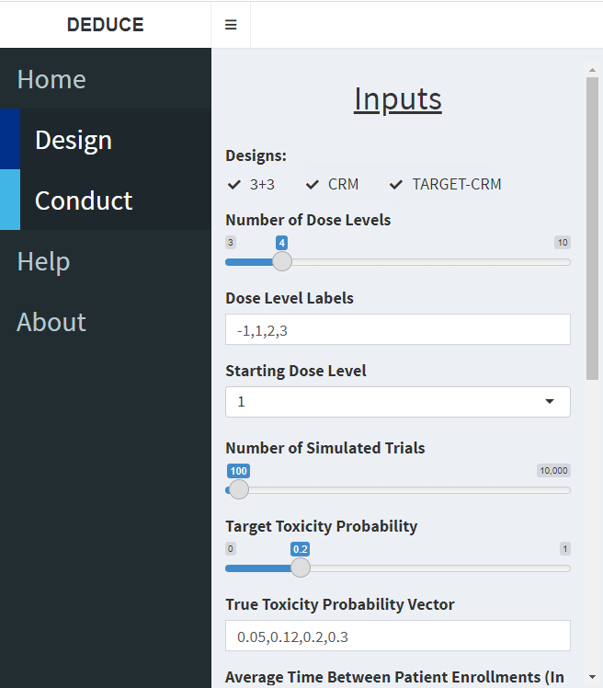 | - Relabel “True Toxicity Probability Vector” as “True Toxicity Probability per Dose Level”.

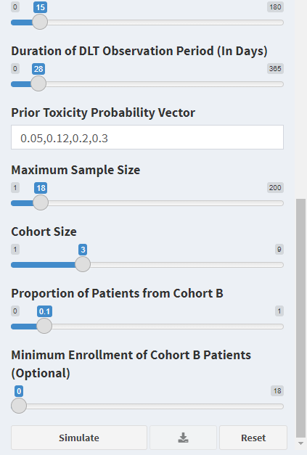 | - Relabel “Prior Toxicity Probability Vector” as “Prior Toxicity Probability per Dose Level”.  - Update help text for “Maximum Sample Size”:  “Please enter the maximum number of patients to be enrolled per trial. Trial accuracy increases with larger sample size. The selected sample size should balance trial accuracy with accrual feasibility.”
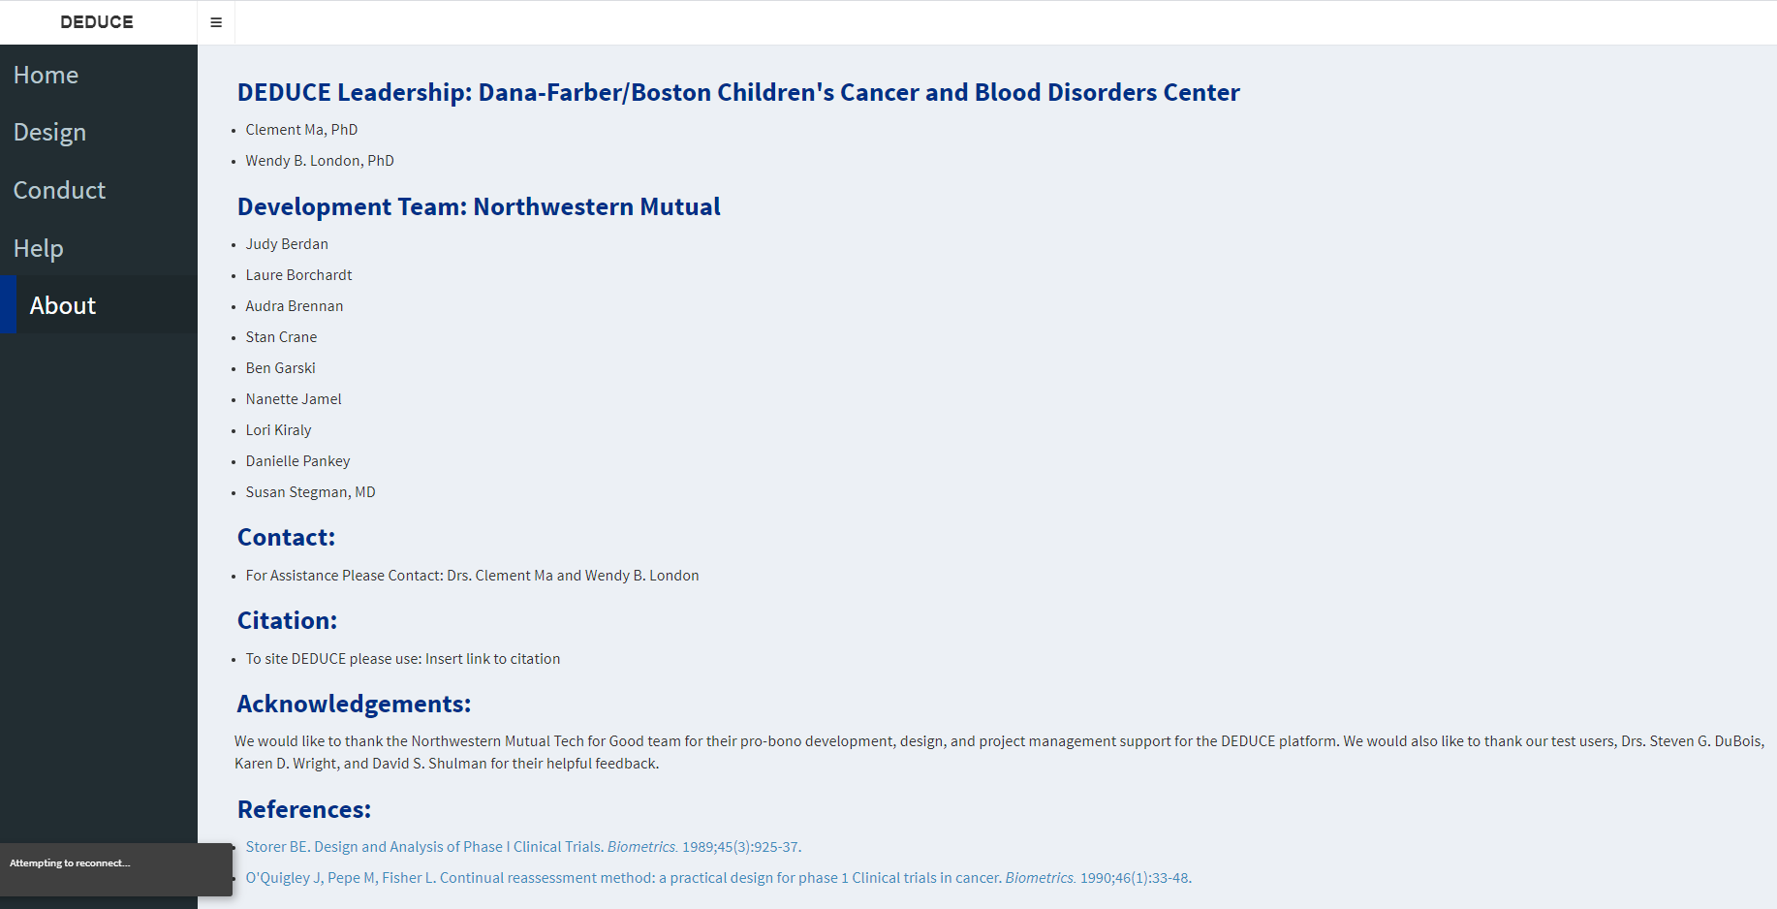 | - Typographical edits:  “For assistance, please contact: Drs. Clement Ma and Wendy B. London.”  - Typographical edits and added reference:  “To cite DEDUCE, please use:  Ma C, Berdan J, Borchardt L, Crane S, Garski, B, Nanette J, Kiraly L, Pankey D, Stegman S, London WB (2021). DEsign and conDUCt of dose Escalation trials (DEDUCE). Available at: https://bengarski.shinyapps.io/DEDUCE/

